In windows 10, DockerToolBox is a complete package of Docker utilities example Docker Compose, Docker Machine, Docker CLI.
When you click on Docker QuickStart Terminal, you get into default docker machine (node).
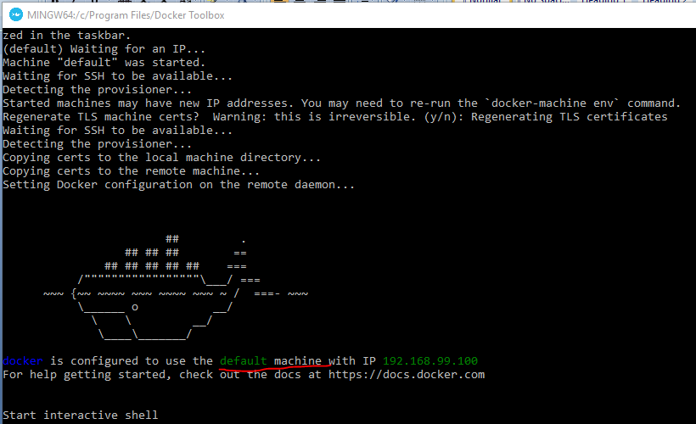
There are other machines:
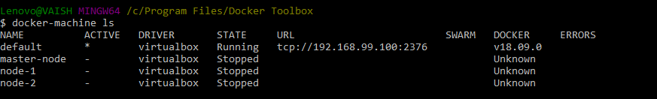
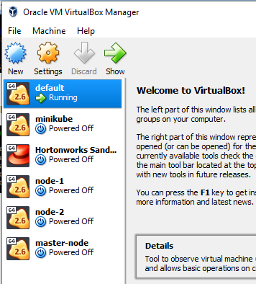

To understand multi nodes concepts go through DockerSwarm document.
Let’s deploy 1 image twice on same docker machine (we will have to choose different port numbers)
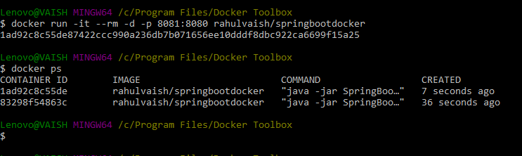
NOTE: rahulvaish/springbootdocker’s Dockerfile is configured to port number 8080. Therefore as we have to deploy one image twice, we have chosen target port as 8080 and 8081 as below:
- docker run -it --rm -d -p 8080:8080 rahulvaish/springbootdocker
- docker run -it --rm -d -p 8081:8080 rahulvaish/springbootdocker
Now lets learn about following switches:
-it means interactive
--rm means it will clear the container after finishing the execution
-d means detached mode.
On launching same image as twice creates 2 containers (on 8080 and 8081). This can be accessed, as below:
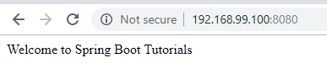
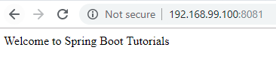
We can stop one:
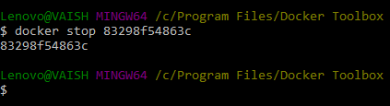
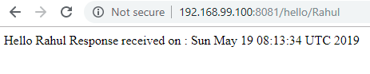
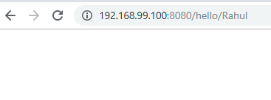
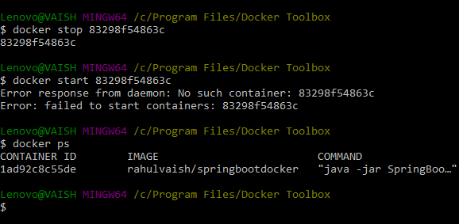
Did you notice that earlier we used --rm switch. The purpose of that switch was to remove the container after its job is done (that could be a natural process exit (example: SOP(“Hello World”))or issuing stop or pause or kill). That is why we were not able to re-start it. Instead if we had not used -- rm switch, the scenario would have been different.

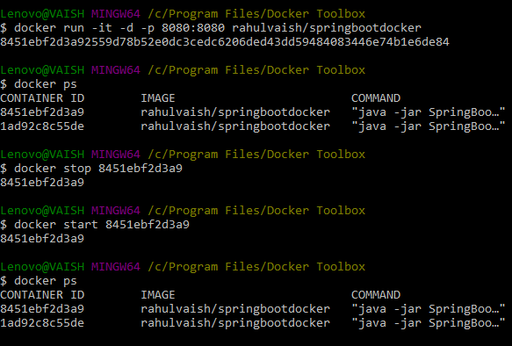

If we don’t use -d switch then, we can also see container logs:
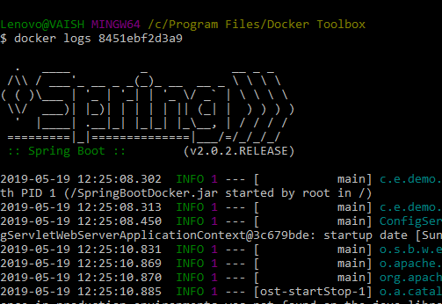
We can also see container statistics:
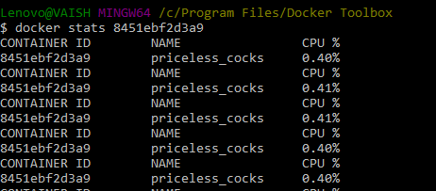
To view port: We have two options [1] docker ps and [2]docker port<container_id>
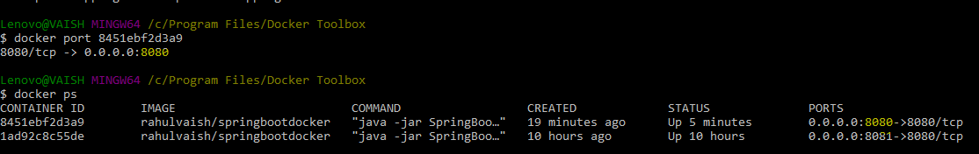
We have already seen that exposed/target ports are 8080 and 8081, pointing to image configured to 8080.
To remove a container: You need to stop, not pause the container!!
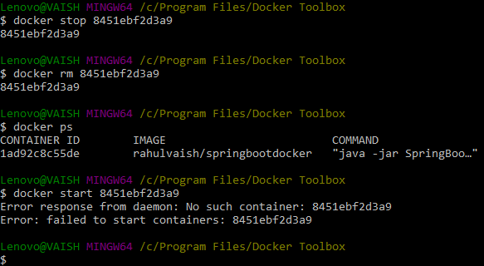

Rename a container:
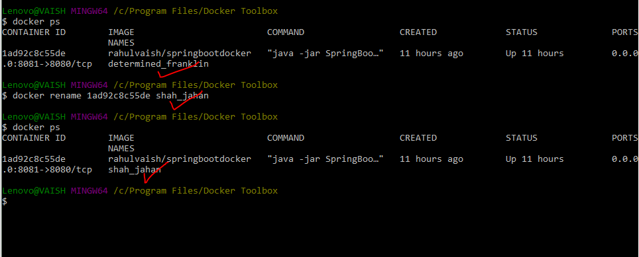
To know the version of docker:
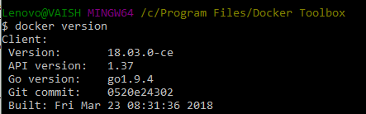
To view the images in your local docker repository, use the below command:
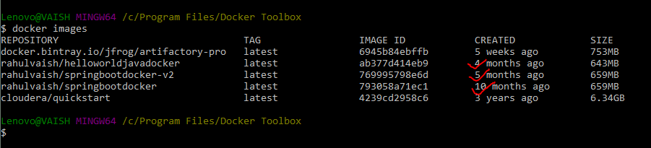
Remember, when we used to pull/run a image, the terminal prompted that unable to find the image locally, and then it started to download the image…. So to check if the image is present locally or not, we can check the same from the above command.
Also, we can see that when these images were actually created. To determine the same we can issue history command.
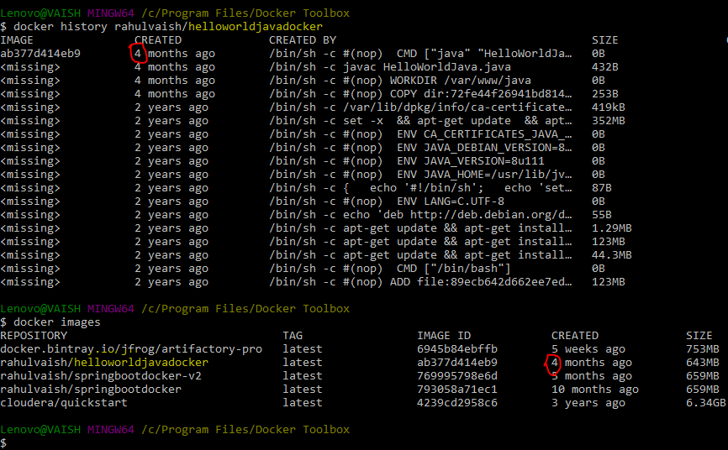

To delete all containers including its volumes use:
docker rm -vf $(docker ps -a -q)
To delete all the images:
docker rmi -f $(docker images -a -q)
P.S. Remember, you should remove all the containers before removing all the images from which those containers were created.
To inspect the container:
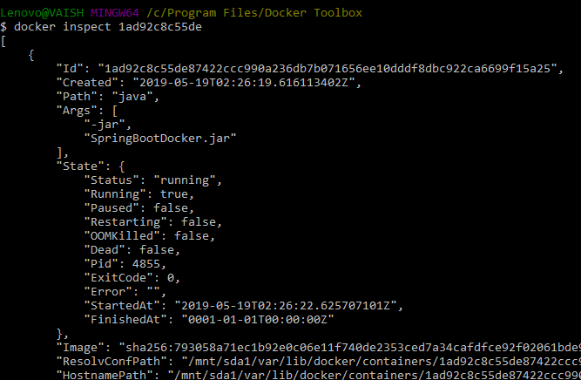

To see how containers died :– A Satisfactory death or unsatisfactory death:
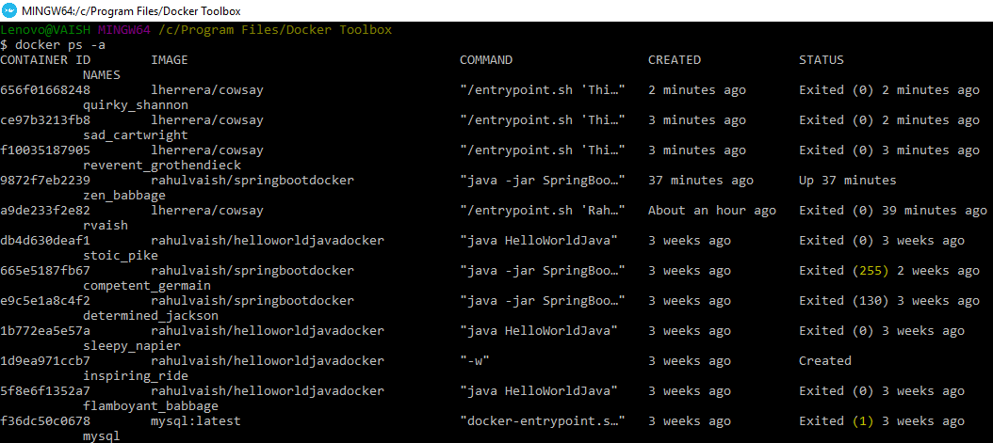
Exited with code 0 means satisfactory death.

Lifecycle of Container:
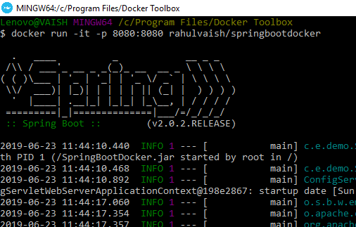
Now, check the events: There are several ways to check and filter the event history:
WAY#1: docker events --since '2013-06-23'
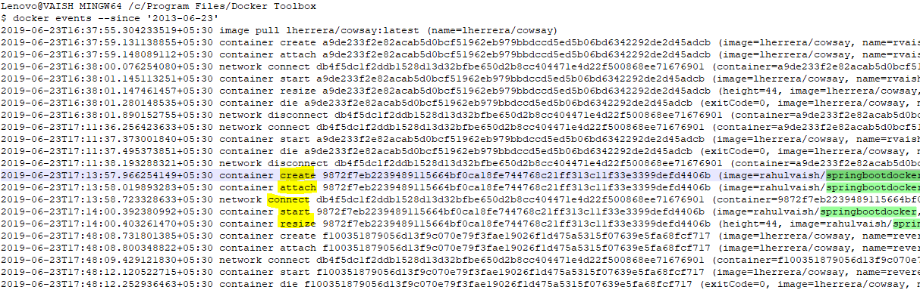
As this above example, the container is alive. Let’s see a complete lifecycle example!
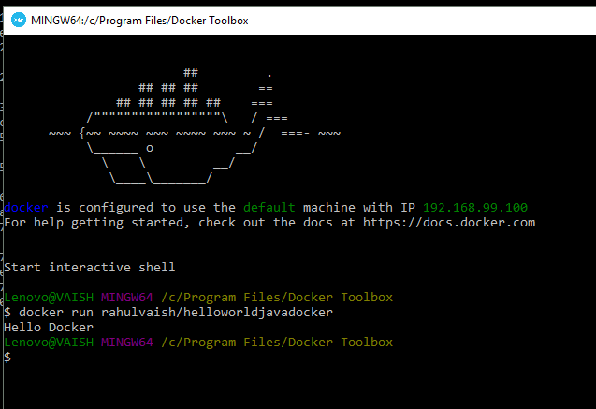
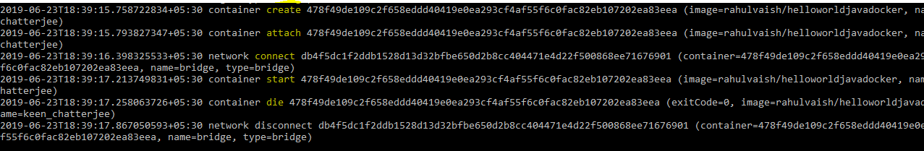

WAY#2: docker events --filter 'image=rahulvaish/springbootdocker' --since '2013-06-23'
